Cloudburst Consulting Group

2015 CFP Impact Evaluation Baseline Data collection

CFP PARTICIPATORY MAPPING INSTRUMENT: TRAINING HANDOUT

This handout contains information on how to facilitate the CFP Participatory Mapping Exercise, and guidelines for effective facilitation and transcription.

PARTICIPATORY MAPPING: BACKGROUND
- Participatory mapping allows a group of people to share information about their community or space by creating a map of it.
- The exercise lets people share their knowledge in a fun and informal way, while also discussing their existing community resources and needs.
- Because everyone knows his or her village, and because mapping is both a visual and verbal process, it is a stimulating exercise and all members of the group are encouraged to participate.

PARTICIPATORY MAPPING: HOW IT WORKS
- Using this tool is quite simple. Groups of people are asked by a facilitator to draw a map of their village. Based on particular research questions of interest, participants are asked to include the village’s infrastructure and primary resources, such as schools, fields, water supplies, etc. They are also asked to identify what spaces and resources are most important to their village.
- During the mapping exercise, an open forum for discussion and sharing information is created. The facilitator listens and works with the group to help guide the process.
- Once the map is complete, the facilitator asks the group to share and explain the image they have created in detail.
- Detailed step-by-step instructions for facilitating mapping exercises are provided on page 7 of this handout

EXAMPLES OF MAPS

The images below are example of maps that were created during a participatory mapping exercise. Notice the different styles and the varying level of detail.

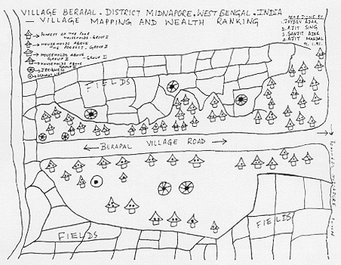

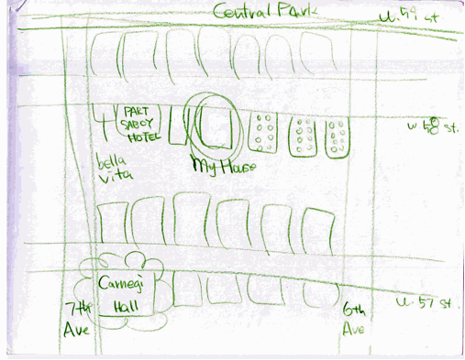

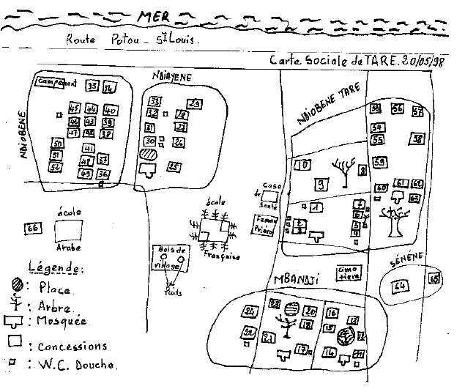

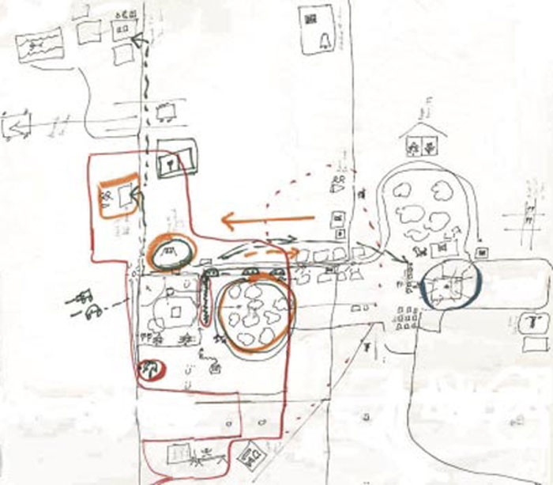

OBJECTIVES OF CFP PARTCIPATORY MAPPING

- The objective of the CFP mapping exercise is to identify the important resources and spaces of a village, and to determine how participants see and rank their environment and resources.
- The goal of the participatory mapping exercise is not for participants to accurately identify the boundaries of a village, or to locate the natural resources correctly, but rather to help participants articulate and communicate their spatial knowledge and understanding of their village.
- By conducting the exercise with men and women separately, the map will also help identify gendered differences in perceptions, needs, and access to resources.

CFP PARTCIPATORY MAPPING PROTOCOL

- The CFP Mapping Protocol is an outline that covers the different steps of the exercise and the topics and issues to be explored.
- The Protocol also includes a checklist indicating all of the important landmarks and spaces that participants should include in their maps.
- The more familiar you are with the Protocol, the easier it will be for you to facilitate the exercise, ask clarifying questions, and to ensure that the exercise runs smoothly.
CFP FGD SAMPLING/GROUP COMPOSITION
- In 20 villages, the research team will complete 2 Participatory Mapping Exercises, including one with men and one with women.
- Each mapping exercise should include 6 to 8 participants.
- In the selection of the 6 to 8 participants heterogeneity of participants is important. Try to include participants with a diversity of experiences and backgrounds so as to capture differences among the population
- Also try to select participants who have lived in the village for at least one year.
- You should consult with the headman and induna for recruitment advice, but remember they are likely to choose relatives or friends if they feel there are benefits to participating.
LOGISTICS
- MATERIALS:
  - Mapping Protocol and writing utensils
  - Mapping Materials: May vary depending on the context, but often includes markers, large sheets of paper, post-its, stickers, construction paper, tape, scissors, etc.
  - Recording equipment: a tape recorder and extra batteries
  - Juice/snacks for participants
- TIME: 1.5 hours to 2 hours
- SPACE: Any private space shielded from the elements where the participants can feel free to talk openly and where the facilitators can take notes and audio record.
- STAFFING:
  - Conducting focus groups requires 2 facilitators, comprised of a lead facilitator to guide the exercise and a note taker who will take hand-written notes and make observations throughout the exercise.

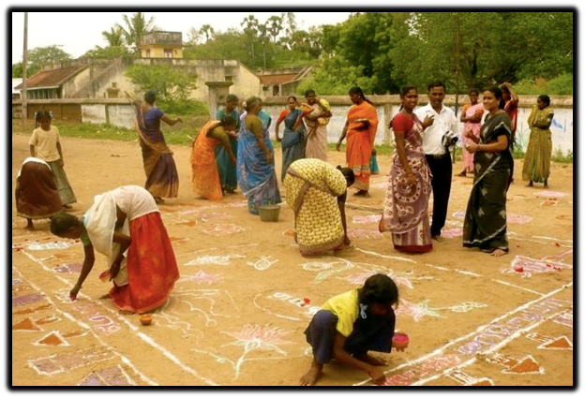

ROLE OF FACILITATOR

- Familiarize yourself with the list of objectives for the CFP participatory mapping exercise, the step-by step directions for facilitating the exercise, and the checklist indicating all the important landmarks or spaces to uncover in the mapping exercise.
- Use the Mapping Protocol checklist to ensure that all topics are covered when facilitating each exercise. This checklist is included in the Mapping Protocol and will help keep in mind what information is needed. The note taker will also use the checklist to help you keep track.
- Try your best to ensure that all the topics are covered during the exercise.
- Try to be as flexible as possible with the informants but do not forget the kind of information you need. Let the participants drive the mapping process, and then if there is missing information that is important for the research objectives, ask them to expand on it.
- At the beginning of each mapping exercise, after you obtain consent from the participants, use the Introductory Script in the Mapping Protocol to outline the purpose and format of the exercise. Explain very carefully the objectives of the exercise, how the session is expected to be developed (duration included) and what the information will be used for.
- Also use the Introductory Script to set some ground rules for the exercise. It is helpful to let everyone know at the beginning of the focus group about some ways to make the discussion proceed smoothly and respectfully for all participants.
- Remember to thank participants for their time and participation.
- Facilitate negotiation among the group members about how the map is drawn. One effective way of achieving this negotiation is to ask the group to nominate a person to draw the map at the outset. Just make sure pens are available for all group members to use, or to hand to the map writer so ownership and interaction is encouraged throughout the mapping for all group members
- Manage the mapping process, not the content
- Pace the exercise: It is important to ensure that the exercise is responsive to the participants approach to drawing while at the same time allowing for the process of description and discussion to happen.
- Remember that the discussion of the maps is equally as important! The discussion of the maps will allow you to fill in any missing information that is important for the research objectives. Also, some things, such as complex relationships among community members cannot be drawn, but the map will provide a visual cue to help participants describe them to you.

ROLE OF NOTE TAKER
- While community members are involved in the activity, take detailed notes of what community members are saying and discussing. Also observe and make notes about group dynamics.
- Manage the digital voice recorder
- Don’t forget to read aloud the village name, village ID number, and type of group at the beginning and end of the recording! Otherwise, it will be very difficult to match the recording to the village.
- Use the checklist in the Mapping Protocol to help the lead facilitator ensure that all topics are covered when facilitating each focus group.
- Turn away potential interrupters/ address other distractions
- Help keep track of time.
- Once the map is complete, label the map with the village name, village ID, and the group type (male or female)
- Take 3 photographs using a phone or tablet. This photograph will be uploaded and saved along with the other information collected during the exercise.
  - Name of the photo should be labeled as: “VillageID_VillageName_MapFemale” or “VillageID_VillageName_MapMale”
- Take the map with you when you leave and keep it stored and undamaged until the end of data collection. Once the data collection team is back in Lusaka, these maps will be sent to the US.

RECORDING AND DATA MANAGEMENT
- Please refer to your ‘Qualitative Data Management Handout’ for instructions on how to manage and upload your Mapping data.

TRANSCRIBING MAPPING EXERCISES

- The creation of the map is a record from the interview. But this cannot stand alone as it is part of the interview. An audio recording of the presentation of the map and the interview to be transcribed and translated is also important.
- Steps 3 to 6 of the mapping exercise must be transcribed, word-for-word in Nyanja and then translated, word-for-word, into English. Please follow to transcription and translating directions from the FGD and DKI training handouts.
- Don’t forget to include the village name, village ID number, type of group (women or men), and the completed roster of respondents in the transcript.
- Also include any of the major themes, observations, or other important information from the hand-written notes.

STEP-BY-STEP DIRECTIONS

- Introduce the mapping exercise to participants (approximately 10 minutes): Explain very carefully the objectives, how the session is expected to be developed (duration included) and what the information will be used for. Explain that your role in the exercise is to watch, ask questions, and listen. (See Introductory Script)
- Mapping (approximately 30 minutes): Participants should draw a map of their community. It is up to the participants to decide the boundaries of the community or space they are mapping, but the boundaries should remain within a border that most people can access by walking or a short drive. Participants should identify all the major landmarks that are important for the community members. If they would like, participants may come up with their own coding system for delineating landmarks (such as color coding, lines, pictures, stickers, etc.). They may also use stickers to identify the most important space and resources on their map.
- Presentation of the map (approximately 10 minutes): Ask participants to share their map. This is the participants’ opportunity to present what they have created to the facilitator(s) and other groups. Pay attention to what they describe as well as what they omit.
- Interview the map (approximately 30-40 minutes): Ask questions about the map. Aim questions at the image itself instead of one specific person when interviewing the map. This will encourage all participants to feel equally able to answer the question. Some suggested clarifying questions are listed below:
  - Why did you choose these landmarks?
  - How did you decide to define the boundaries of the community?
  - What three places are you most likely to frequent?
  - With what three places are you least likely to be familiar?
  - Where are the transportation points?
- Identify important landmarks (approximately 15 minutes): If you have not done so already, identify all the landmarks listed in your checklist. Ask about the landmarks that were unknown or unexpected. Identify points of interest to the CFP research (e.g. forests, fields, water sources, etc.) and ask clarifying questions. ALSO ASK ABOUT THE LANDMARKS ON YOUR CHECKLIST THAT ARE NOT INCLUDED IN THE MAP.
- Conclude the exercise: Thank the participants for their generosity of time and contributions during the activity, explaining to them how the research will be used in the future.
- Record the map and transcribe the discussions: Label and take a photograph of the map and save it along with the notes and recording collected during the exercise. Transcribe the recorded discussions from steps 3 to 6.
→ GROUP EXERCISE: CREATING A MAP OF LUSAKA

